Avanza, Virtu, ISK, and Crest

Last update: 26/05/2021

Translation from original reddit post, courtesy of Squirrel:

https://www.reddit.com/r/ISKbets/comments/nlm5h9/kan_vi_p%C3%A5_n%C3%A5got_s%C3%A4tt_ta_reda_p%C3%A5_antalet_aktier/

Hello, I own X number of shares in the company Gamestop via an ISK account on Avanza. Gamestop will have an annual meeting in June, and before that a vote will take place. The vote requires a control number for the shares that I own, which only Avanza can give me. Unfortunately, Avanza is refusing to answer my request for a control number. Furthermore I cannot get the certificate of ownership from the shares I purchased in contrast of their terms of use.

I have been in contact with their customer support however they are not answering my questions but rather trying to avoid them. As an owner of GME shares, I am technically a partner, therefore I have a right to vote at the general meeting. But without the certificate of ownership that is not possible. I have received information that other customers are neither able to obtain the information (certificate). According to Avanza's website which explains how an ISK account works, it is clear that I should have the right to vote. (See link below). Link:

("Scroll down and see "Voting rights at the Annual General Meeting")

Thank you

Questions without answer:

*Can a brokerage have their property in a custodian, and still use it for things like trading and leverage?*

*Maybe Morgan is the replacement to Virtu who was the criminal connection ?*

HYPOTHESIS SO FAR:

1 thing about this whole situation is that the HFs knew what they were doing and doubled down because they thought we were dumb. I'd imagine if EU could rehypothecate infinite more assets than the US they would not have limited their exposure before Jan.

<https://www.crestfinancialgroup.com/>

The crest financial is handling roughly 250m which would not be enough to access dark pools and higher level trades.

So Crest isn’t guilty, they’re just the tunnel. Crest would not know about darkpools, they’d only be carrying the 140%+ rehypos from here where they have to be created to London to get to Sweden. Here we can see what exchanges we traded on, and what providers handled things, as part of the data

Because if Crest wasn’t piping in the rehypos, they wouldn’t be for sale in Sweden. They’re perfect counterfeits. But Crest does know what it’s doing the sense that this practice between the US and London is much older than the current events.

Not doing the work of them.

We have the Crest connection to London so we can rehypo above 140% we just have to stash it in London.

I believe Crest is why the Euro nations are being hit first / the hardest

Who over there would be able to access dark pools at a top level ?: Cross reference the answer to that question with anyone else found

The rehypothecation above 140% had to take place entirely in darkpools or we’d know it, and it’d be illegal. So that means they went out via Crest, as a starting point. Whoever can access darkpools, crest, and your people, it’s them.

The top broker is Avanza in sweden, you can also open an investment savings account called "ISK account" in other banks like Swedbank etc, but these are more focused on banking rather than buying and selling shares. I set about finding out how they’d do that and Crest is it

So where is Avanza supposedly buying all the shares from? They used to buy their shares from **Virtu Financial inc.**

But apparently changed that just recently to **Morgan Stanley** or so: Must have been just recently, probably when people started bashing them about voting rights etc two or three weeks ago. I sent an email asking them which broker they have used, which one they use right now and if Virtu ever was involved.

They bought the RFUK DPTF but it contained contents that weren’t legal in Sweden. By the time anyone knew, was after the USA was known to be at 140%. Those in control here behind the scenes swapped out any real shares they had. To return them to the US for the fight here, and I imagine they were paid very well for these. But they still thought they had it under control, that if the Swedish people came a calling for their sales, they’d just pay you

But it has gotten much, much worse since lets give them credit for being ahead of us Apes, they could have been trying to manage this in Nov or Dec or even earlier (Keith Gill was onto a piece of it, with just the intel he could get, imagine what you could do with the intel if you did these things and knew it 100% to be true)

And they got greedy, complacent, and sure that no way we could topple it over and force exposure.

https://www.fiduciary-trust.com/insights/choosing-the-right-custodian/

” Assets held in bank custodial accounts generally never become assets or liabilities of the bank (the title is held by the owner(s) of the accounts) and therefore should not be subject to the claims of the bank’s creditors. As a result, a failure of a bank should have no adverse effect on custodial accounts since they remain the property of the account’s owner(s). Assets held at a brokerage firm may be included on that firm’s balance sheet and may also be lent or otherwise “re-hypothecated” behind the scenes. If a brokerage firm should fail, during the receivership period it’s likely that your clients will be required to “get in line” with other creditors and hope that SIPC and any supplemental insurance policies help ease the pain.”

https://www.imf.org/en/Publications/WP/Issues/2016/12/31/The-Sizable-Role-of-Rehypothecation-in-the-Shadow-Banking-System-24075 https://www.imf.org/-/media/Websites/IMF/imported-full-text-pdf/external/pubs/ft/wp/2010/_wp10172.ashx

https://whalewisdom.com/filer/bnp-paribas-arbitrage-sa#tabholdings_tab_link

https://sec.report/Document/0001533964-21-000004/

https://www.nasdaq.com/market-activity/stocks/gme/institutional-holdings

With the people I know that hold GME, our shares in total add up to almost 1k split amongst 5 people. I doubt that the average number of shares that people have is 1 or 2. But if all of us have a maximum of 2 shares on our accounts per individual on Avanza; that's 43 136 shares. Paribas holds 26 092 shares according the screen shot above.

That's 17 044 shares not accounted for.

PNG Paribas is known for being shady AF, just see what they’ve done in the past; https://www.rfi.fr/en/france/20210521-bnp-paribas-charged-in-france-for-laundering-assets-linked-to-gabon-omar-bongo-atelier-74

“BNP Paribas, one of France’s leading banks, has been indicted on suspicion of laundering tens of millions of euros of Gabonese public money stemming from corruption and embezzlement. It’s the latest development in a long-running investigation into luxury real estate acquired in France by the family of the late president of Gabon Omar Bongo.” https://www.justice.gov/opa/pr/bnp-paribas-sentenced-conspiring-violate-international-emergency-economic-powers-act-and

“BNP Paribas S.A. (BNPP), a global financial institution headquartered in Paris, was sentenced today for conspiring to violate the International Emergency Economic Powers Act (IEEPA) and the Trading with the Enemy Act (TWEA) by processing billions of dollars of transactions through the U.S. financial system on behalf of Sudanese, Iranian and Cuban entities subject to U.S. economic sanctions. BNPP was sentenced to a five-year term of probation, and ordered to forfeit $8,833,600,000 to the United States and to pay a $140,000,000 fine. Today’s sentencing is the first time a financial institution has been convicted and sentenced for violations of U.S. economic sanctions, and the total financial penalty—including the forfeiture and criminal fine—is the largest financial penalty ever imposed in a criminal case.” https://www.fxloans.org/bnp-paribas-sentenced-to-return-millions-of-euros/

“This past Wednesday, February 26, BNP Paribas Personal Finance has been condemned to pay the maximum fine possible, 187.500€, plus tremendous damages, for covering the risks induced by its loans inherent in the Helvet Immo mortgage. This scam has affected more than 4,600 borrowers.”

Brokers I utlandet Avanza –

https://www.avanza.se/aza/depa/blanketter/Avanza%20International.pdf

https://www.reddit.com/r/ISKbets/comments/nkxnwd/gme_betyder_detta_att_dom_inte_har/

Odd excuse again, saying that they do not have the possibility to manually provide ownership evidence in the regard that is asked by customers. Avanza state that they simply do not have an optimal solution for this in a purely administrative way.

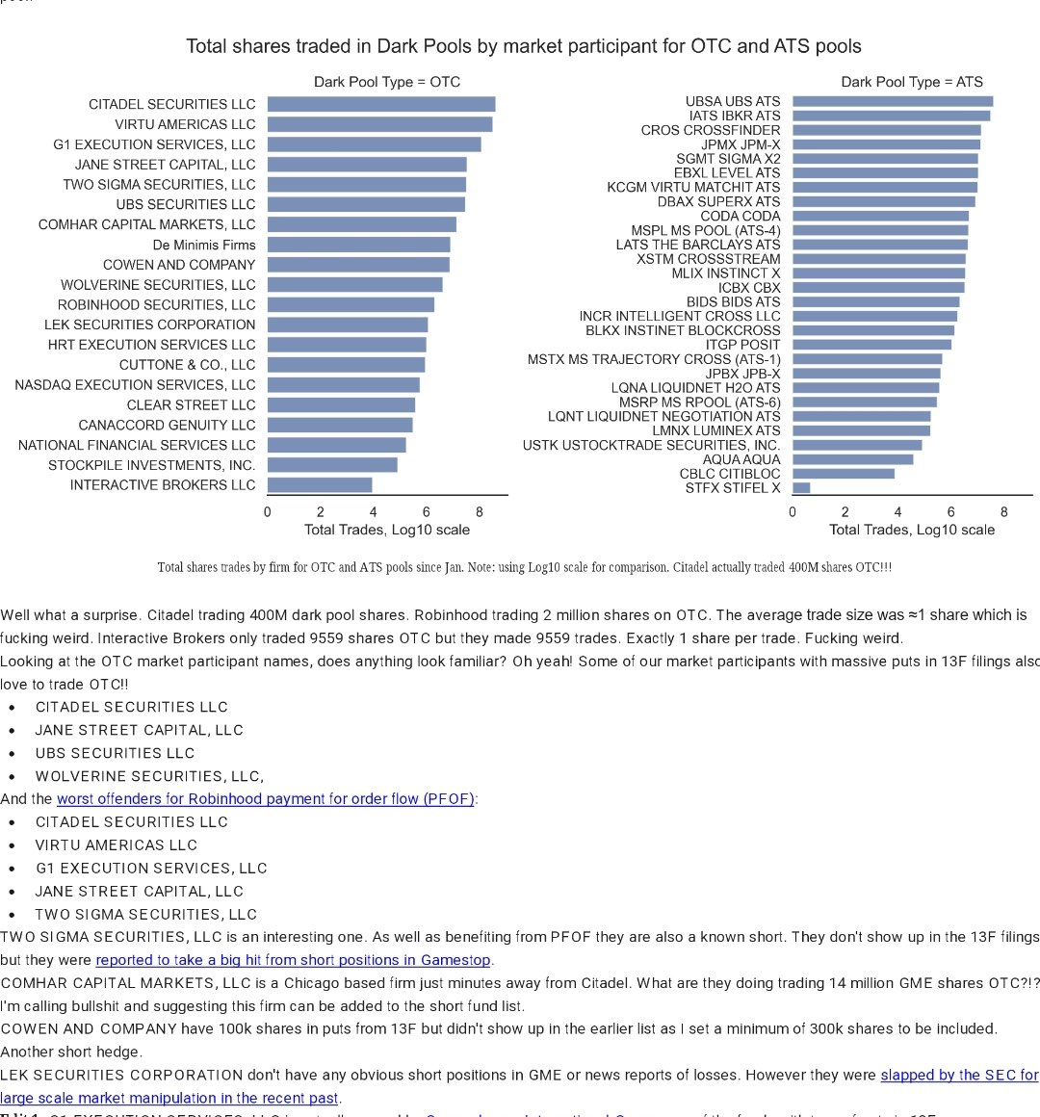

In second place after Citadel themselves, Virtu

**Virtu would need a connection and that would complete the circuit. Then we start eliminating everyone on the circuit and whoever doesn’t get eliminated is guilty in part.**

But given their 2nd place size, it would seem to maybe be possible if you were holding all of several countries worth in synthetics.

CREST is different from crest financial. CREST appears to be a bottleneck between US and UK and possibly the rest of eu.

Avanza is the Sweden broker. They get their shares from Virtu, which just so happens to be the 2nd largest darkpool trader to Citadel.

Avanza then sends shares to a custodian bank, BNP Paribas. So what are custodian banks? They hold securities, basically a bank for banks if I’m understanding correctly. https://www.fiduciary-trust.com/insights/choosing-the-right-custodian/

So I'm rereading this over and over and I think what it's saying is that brokerages that hold shares rehypothecate those and custodian banks don't.

So I googled Custodian bank rehypothecation to find out and landed on this wild as fuck document written in 2010 by the fucking former prime minister of India. They go deep into rehypothecation and the relationship between the UK and US markets. UK has no limit on rehypothecation and can infinitely loan money using your assets as collateral.

https://www.imf.org/-/media/Websites/IMF/imported-full-text-pdf/external/pubs/ft/wp/2010/_wp10172.ashx

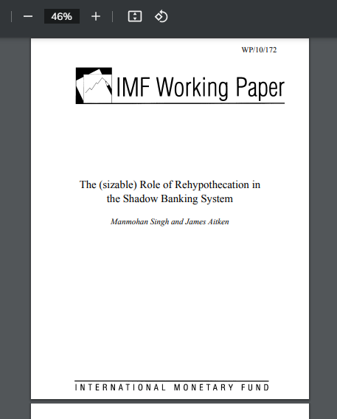

I want to find out if they are even required to report the churning rate. (Churning rate referenced in the document is basically how much they are loaning money out on each asset... aka NAKED SHORTING)

I am trying to contact the co author of the document, since I highly doubt I'll be able to talk with the former Prime Minister

So jumping back to VIRTU here is their position in GME:

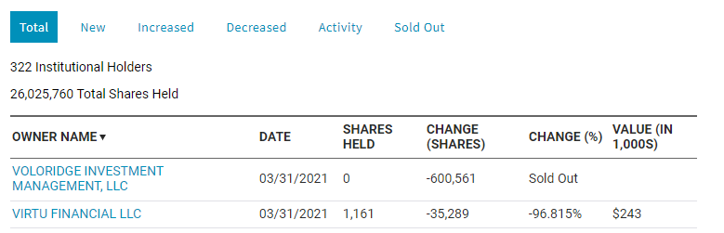

For comparison this is Citadels:

https://cdn.discordapp.com/attachments/847116937510518814/847182207546425364/unknown.png

These 13Fs don't report the short positions, and these numbers are from March

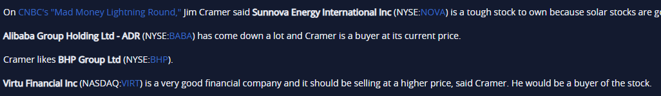



Well shit if Jim Cramer is singing their praises, exactly today, they must be guilty (26/05/2021)